36.59: a) For eight slits, the phasor diagrams must have eight vectors:

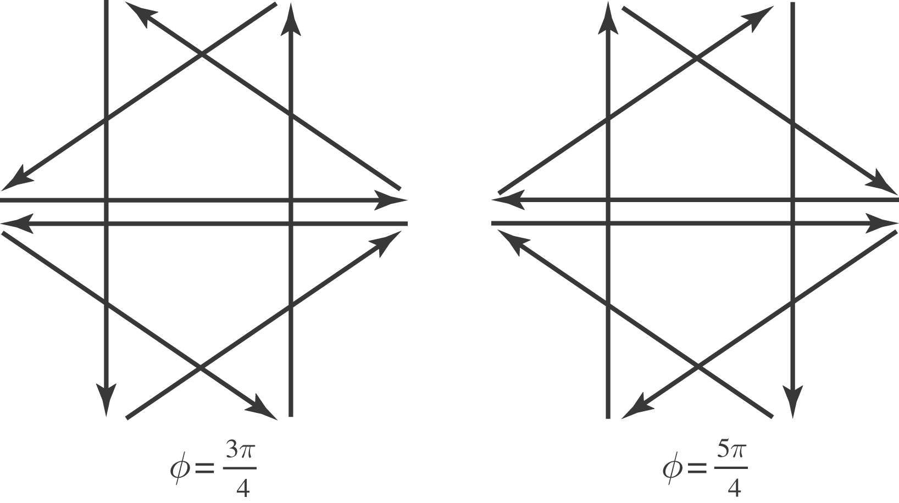

b) For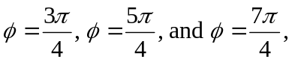 totally destructive interference occurs between slits four apart. For 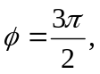 totally destructive interference occurs with every second slit.

